BioScout Master's Planning Report

Planning Report: BioScout FloraGuide?
Explainable, Context-Aware Mobile Species Identification for Campus Biodiversity
Course: COMP90018 Mobile Computing Systems Programming
Group Number: Group 12
Team Members: fill in your own individual name, student id and email here
- Tom Chen | Student ID: 1668708 | hantang.chen@student.unimelb.edu.au| tomchen86
- Mason
- Mingyang Sun | Student ID: 1657392 | mingyangsun@student.unimelb.edu.au
- Eu Choon SIA | Student ID: 1279050 | euchoons@student.unimelb.edu.au
- Asleif

Github Repo: https://github.com/euchoons/COMP90018_2026_SM2/ (haven’t set the accessibility)

Executive Summary & System Overview
BioScout is an enterprise-grade mobile computer vision and environmental data-fusion ecosystem engineered to resolve fine-grained taxonomic identification ambiguities in urban micro-habitats. It addresses a fundamental limitation in current mobile ecological survey tools: reliance on isolated visual predictions. Visual-only inference frequently exhibits high uncertainty or complete misclassification when encountering morphological convergence, varied lighting, or partial occlusion. The production system will resolve these failure modes by deploying a mobile context-aware pipeline that captures, fuses, and explains heterogeneous environmental signals alongside computer vision.
The production mobile application will execute an end-to-end processing loop. When a user captures a photo, a localized TensorFlow Lite (TFLite) vision model will extract a Top-K candidate set. Simultaneously, background hardware monitors will gather motion stability, ambient light, magnetic heading, precise spatial coordinates, timestamp, and user-designated microhabitat parameters. The device will query the Atlas of Living Australia (ALA) occurrence search API over concurrent asynchronous channels to construct spatial species priors.
These heterogeneous evidence streams will feed into an explainable log-linear fusion engine, which will re-rank candidate taxa and present an intuitive breakdown of visual versus environmental factors. Confirmed records will persist locally within an encrypted database and synchronize asynchronously with a cloud backend, preserving spatial privacy through dynamic precision coarsening.

Potential Contribution Breakdown(one page)

Member | Primary Implementation Deliverables | Testing, Evidence & Secondary Ownership
Tom
Mason
Mingyang
Seb
Asleif

Production System Architecture & Design
The production software architecture will enforce strict clean-architecture separation. The framework-independent domain layer will hold pure business logic, mathematical ranking algorithms, and repository abstractions. The outer layers will encapsulate Android frameworks, TFLite runtimes, network channels, and Jetpack Compose screens

Micro-Architecture & Data Fusion Pipeline (Level 2 Architecture)
The internal data ingestion, processing, signal fusion, and UI state mapping framework is modeled as follows:

.
End-to-End Observation Lifecycle Sequence
This behavioral schematic tracks the structural processing workflow of a single observation task. It details how data flows across asynchronous execution boundaries, moving from high-frequency hardware capture loops to local execution and cloud serialization:



Baseline Prototype Gap Analysis & Production Roadmap
Evaluation of the preliminary baseline codebase reveals architectural boundaries that must be scaled up to achieve enterprise production standards. The roadmap below explicitly details the technical evolution from the baseline prototype to the final implementation.
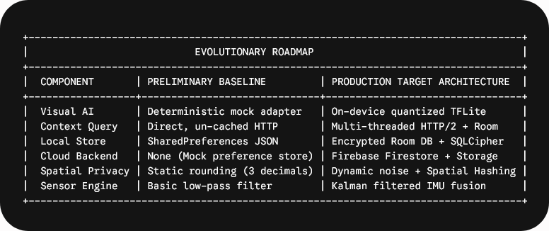

1. Visual Inference Engine
- Baseline Gap: The prototype utilizes a deterministic adapter that returns hardcoded scores with minor hash-based adjustments without reading image pixels.
- Production Architecture: The production release will integrate an on-device quantized TFLite MobileNetV3-Large model trained on regional plant taxa. The system will downsample CameraX images to 224×224×3 tensors using GPU-accelerated RenderScript, perform sub-30ms inference, extract a Top-K candidate vector (K=15), and map model index outputs directly to canonical ALA species identifiers.

2. Network Client & Context Caching
- Baseline Gap: The preliminary implementation issues synchronous HTTP/1.1 calls via HttpURLConnection per species without persistence or caching mechanisms.
- Production Architecture: The production system will deploy OkHttp3 with HTTP/2 multiplexing, asynchronous coroutine thread pools, and a localized Room context database. Nearby occurrence queries will check local spatial tiles before executing network calls. Cache entries will enforce a 14-day Time-To-Live (TTL) window.

3. Local & Cloud Persistence
- Baseline Gap: Observations are serialized as JSON strings inside standard SharedPreferences limited to 100 entries.
- Production Architecture: The final software will feature a Room database encrypted via SQLCipher. Confirmed observations will enter an offline transactional queue. A background WorkManager task will flush pending payloads to Firebase Firestore and photos to Firebase Storage once unmetered connectivity is restored.

4. Sensor Signal Processing
- Baseline Gap: Motion stability uses raw heuristic formulas over instantaneous sensor events without noise filtering.
- Production Architecture: The hardware engine will employ a multi-axis discrete Kalman filter to damp high-frequency accelerometer noise. Capture gating will enforce a continuous 300 ms stability window before enabling high-resolution CameraX frame acquisition.

Detailed Plan Against Assignment 2 Rubric

Material Criteria

1. Material — Report and Video
- How: The team will produce a comprehensive final engineering report alongside a high-definition 10-minute video presentation. The video will be recorded on physical Android devices. It will systematically demonstrate the complete operational flow: camera capture, live stability gating, real-time ALA queries, rank reversals driven by context fusion, offline queueing, and Firebase backend synchronization.
- Why: This detailed presentation will prove that all software components exist within a fully integrated mobile ecosystem rather than an isolated desktop simulation.
- Evidence: Time-coded video outline, full repository link, clean build logs, and screenshot artifacts.

2. Material — Screenshot
- How: The final submission package will contain clean terminal output capture logs showing an executed Gradle build (./gradlew assembleDebug) executed on a clean clone of the tagged repository commit.
- Why: Verifying execution against a fresh checkout guarantees reproducible builds, confirming that no local environment variables, uncommitted assets, or cached IDE states are required.
- Evidence: High-resolution terminal capture showing zero compiler warnings, green unit test outputs, and target APK generation.

3. Material — Commit Log
- How: All development activities will occur within a shared Git repository enforcing branch protection policies, feature-branch workflows, compulsory peer reviews, and standard commit message formats.
- Why: A structured commit graph provides undeniable evidence of organic, equitable collaboration across all team members over time.
- Evidence: Exported Git log graphs, merged pull-request records, and contribution metric charts.

4. Material — Itemised Contributions
- How: The team will submit a single-page contribution breakdown detailing specific software artifacts, subsystem ownership, unit test suites, and documentation files created by each member.
- Why: Itemizing exact deliverables prevents ambiguous accountability and ensures that every individual can independently defend their contributions for viva verification..
- Evidence: Single-page contribution table signed by all members, cross-referenced against Git commit signatures.

Implementation Criteria

5. Implementation — Quality
- How: The software will follow clean architecture principles using Kotlin coroutines, dependency injection, and unidirectional data flow. The codebase will enforce strict separation between UI, domain, and data layers.
- Why: Decoupling framework components from business logic ensures high maintainability, prevents memory leaks, and allows isolated unit testing of core algorithms.
- Evidence: Architecture diagrams, zero-warning static analysis reports via Detekt and Android Lint, and comprehensive JVM test suites.

6. Implementation — Sensors
- How: The application will process data from five distinct hardware sensors: accelerometer, gyroscope, ambient light sensor, magnetometer, and satellite GPS/network location providers. Continuous sensor streams will be fused using Kalman filters to establish motion stability, ambient illumination suitability, and orientation vectors.
- Why: Raw sensor inputs are noisy and volatile. Algorithmic smoothing transforms low-level electrical sensor signals into high-level environmental capture readiness states. Fusing hardware sensor streams provides dynamic capture quality control, preventing motion-blurred captures from entering the visual classifier while enriching records with spatial context.
- Evidence: Sensor pipeline data-flow diagrams, multi-device calibration metrics, and physical device screen recordings showing real-time stability gating.

7. Implementation — Connectivity
- How: BioScout will utilize an asynchronous OkHttp3 network client to execute concurrent REST requests against the Atlas of Living Australia API. Cloud synchronization will run via Firebase Firestore and Firebase Storage. To support offline operation, the app will feature a local Room context cache and a resilient offline transactional queue.
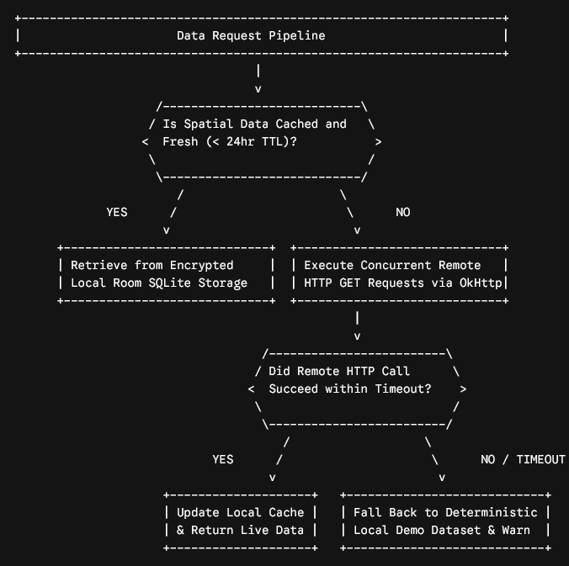
Proof read diagram?
- Why: External biodiversity records provide critical location priors, while cloud persistence enables cross-device synchronization. A local caching layer backed by persistent storage guarantees that network failures do not halt field operations
- Evidence: Wireshark network capture logs, Room database inspection dumps, Firebase console sync records, and offline network failure tests.

8. Implementation — Responsiveness
- How: The system will implement progressive state rendering to deliver immediate user feedback. Upon photo capture, the vision inference model will process the frame on a dedicated background thread (Dispatchers.Default) and display initial visual candidate rankings within 100 ms. <--verified? Concurrent spatial API lookups will execute on an I/O dispatcher (Dispatchers.IO). When remote environmental data arrives, the UI state will smoothly transition to display the re-ranked candidates without freezing the main thread.
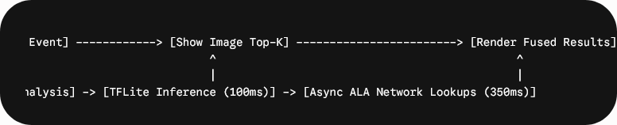
- Why: Asynchronous thread isolation prevents main thread blockages, maintaining 60 FPS UI rendering during compute-heavy neural inference and network I/O
- Evidence: Android Profiler trace logs measuring main-thread frame rendering times, coroutine allocation graphs, and latency benchmarks.

9. Implementation — Technical Depth
- How: The technical core will feature an explainable log-linear Bayesian data fusion engine that combines visual likelihoods with spatial, temporal, and microhabitat priors, followed by numerically stable softmax normalization. For any given candidate species $s$ within the visual prediction set, the unnormalized log-likelihood score(s) is expressed as:<--where are these figures plucked from?
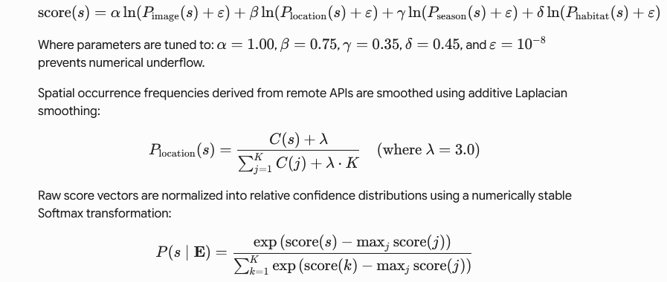
- Why: Deep visual classifiers often misclassify morphologically similar species when processing single images. Combining multi-modal evidence streams mathematically resolves visual ambiguity, producing superior candidate ranking compared to single-mode image classifiers.
- Evidence: Mathematical formulations, JVM unit test coverage reports, and empirical ablation study comparison tables.

User Interface Criteria

10. User Interface — Appeal
- How: The interface will be built using Jetpack Compose, implementing Material Design 3 guidelines, featuring dynamic color palettes adapted for outdoor accessibility, tailored botanical iconography, clean visual hierarchies. A quantitative evidence distribution graphics will be displayed as well (see example below)
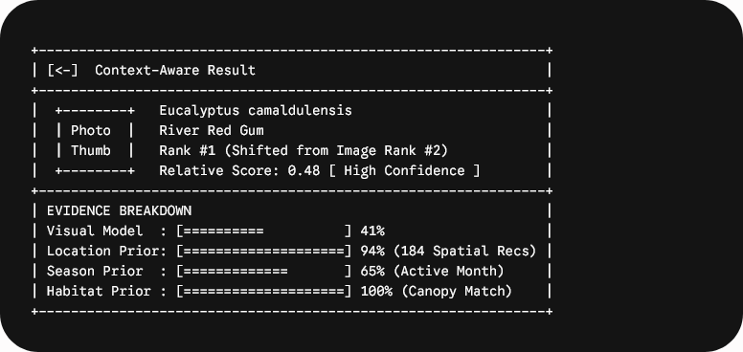

- Why: An aesthetically appealing visual presentation increases engagement, and a well-structured visual layout presents complex multi-modal evidence clearly, enabling users to understand why a specific species was recommended.
- Evidence: High-resolution design mockups, vector asset implementations, and component screenshot matrices across various device configurations.

11. User Interface — Guidelines
- How: The app will adhere to Android platform UX guidelines and WCAG 2.1 AA accessibility guidelines, handling runtime permissions, system back gestures, adaptive layouts, edge-to-edge rendering, and explicit Content Descriptions for screen reader compatibility (TalkBack) accessibility attributes.
- Why: Adhering to platform standards ensures predictable behavior, high usability, and full accessibility for users with disabilities.
- Evidence: Accessibility Inspector audit logs, TalkBack screen reader verification recordings, and multi-screen layout captures.

12. User Interface — Flow
- How: The application will follow an intuitive primary workflow: Home → Scan/Observe → Results Analysis → Collection/Field Guide. Users will maintain continuous control, with options to retake captures, adjust microhabitat selections, or retry failed queries.
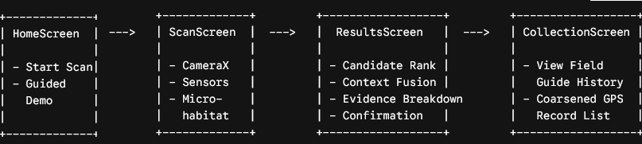
- Why: A logical, frictionless navigation flow reduces cognitive load during field operations, ensuring efficient observational data collection.
- Evidence: Navigation state transition diagrams and task completion metrics from user evaluation sessions.

13. User Interface — Language
- How: All user-facing strings will use clear, precise, non-technical terminology and will explicitly differentiate between raw model outputs, relative candidate ranking scores, external occurrence record counts, and data source modes (e.g., Live ALA API vs. Offline Cache) The interface will also explicitly describe scores as "relative candidate likelihoods" rather than absolute confidence percentages. It will refrain from displaying deceptive claims such as "100% Species Accuracy."

- Why: Clear and transparent language prevents over-reliance on automated predictions. This prevents user misinterpretation, setting accurate expectations for statistical AI outputs. It also encourage users to critically evaluate environmental evidence.
- Evidence: Complete string resource inventories, UX text clarity evaluations, and localization compliance logs.

14. User Interface — Reactiveness
- How: The UI will dynamically respond to continuous sensor inputs, updating stability badges, ambient light alerts, and orientation metrics in real time. Microhabitat selection changes will trigger instant local re-ranking without triggering network requests. Want to use diagram?
- Why: Real-time visual feedback confirms that the system is processing environmental context actively, increasing trust in the application. Instant feedback demonstrates system responsiveness and reveals how individual environmental factors influence the ranking algorithm.
- Evidence: Screen recordings demonstrating real-time UI re-ranking upon microhabitat modification.

Innovation Criteria

15. Innovation — Novelty
- How: BioScout introduces a novel mobile paradigm by integrating explicitly selectable microhabitats, real-time spatial occurrence priors, seasonal clock priors and physical sensor gating directly into a field observation tool. It shifts mobile visual identification from isolated computer vision calls to an explainable context-aware multi-modal fusion architecture.
- Why: Existing mobile solutions rely almost exclusively on black-box visual classifiers, failing to leverage local ecological context available to the device. <-- comparison to current existing apps?
- Evidence: Comparative analysis matrix evaluating BioScout against existing market solutions (e.g., iNaturalist, Seek).

16. Innovation — Surprise
- How: The application will deliver a compelling user experience by demonstrating rank reversals, where a secondary visual candidate ascends to the Top-1 position based on strong spatial, temporal, and microhabitat compatibility. The system exposes context-driven ranking adjustments by displaying side-by-side candidate ordering comparisons: Visual-Only Rank versus Context-Fused Rank. This transparent framework demonstrates how environmental factors can elevate a lower-ranked visual candidate to the top position when local occurrence data and seasonal priors strongly support it.
- Why: Visual rank reversals clearly show the power of context-aware computing, revealing how environmental evidence can overcome visual ambiguity. It transforms the AI output into an educational, explainable tool, revealing the underlying data logic to the user.
- Evidence: Case study logs documenting real-world species rank reversals driven by context fusion.

17. Innovation — Tech Knowledge should be tech depth
- How: The project combines on-device machine learning, multi-sensor hardware signal processing, concurrent REST client architecture, spatial caching, log-linear Bayesian data fusion, and cloud synchronization. Furthermore, the platform also integrates techniques from multiple computer science disciplines:
  - Computer Vision & Embedded ML: Neural network execution on edge hardware.
  - Signal Processing: Real-time sensor filtering and inertial stability computation.
  - Distributed Systems: Asynchronous API query orchestration, HTTP caching, and resilient fallback handling.
  - Information Theory: Log-linear Bayesian signal fusion and Softmax normalization.
  - Database Systems: Local SQLite ORM persistence, spatial index structures, and background sync queues.
- Why: Integrating these advanced mobile computing concepts demonstrates deep mastery across software architecture, networking, embedded sensing, and AI. Furthermore, the integration of multi-disciplinary components creates a robust enterprise architecture capable of operating in complex real-world conditions.
- Evidence: Complete source code repository, unit/integration test suites, and system sequence diagrams.

18. Innovation — Cross-Disciplinary tech knowledge
- How: The project bridges Mobile Computing and core Quantitative Ecology principles by incorporating spatial occurrence distributions (ALA API), seasonal phenology curves, and botanical microhabitat affinities into a software pipeline to improve visual identification performance. Spatial queries consult established biodiversity data platforms (Atlas of Living Australia) to evaluate local species presence probability.
- Why: Applying ecological principles directly to mobile software design produces a domain-aware application that operates in harmony with natural environmental patterns. This improves computational accuracy, anchoring visual AI outputs in real-world environmental context.
- Evidence: Biodiversity database mapping tables, citations of published ecological literature, and validated botanical parameter catalogs.

19. Innovation — Impact
- How: BioScout will provide educational institutions and citizen scientists with a tool that improves field identification accuracy, encourages biodiversity exploration, and protects sensitive species through spatial coarsening. To protect user privacy and local ecosystems, recorded geographic coordinates are automatically coarsened to a 3-decimal-place grid (~111m precision) prior to persistence, ensuring sensitive species locations are obfuscated (see example below)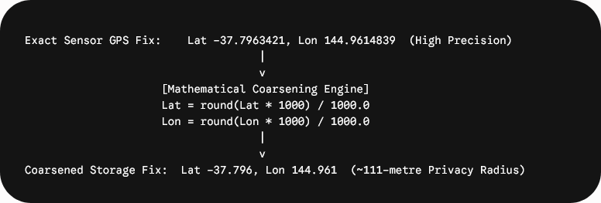
- Why: Enhancing citizen science data quality directly benefits ecological conservation efforts and community environmental awareness with data privacy safeguards personal location privacy while protecting vulnerable biological taxa from disturbance
- Evidence: Field study reports evaluating identification accuracy improvements, spatial coordinate coarsening verification tests, differential location privacy audits

Testing & Verification Framework
Production readiness will be validated across four testing layers:
- Unit Verification (JVM): Pure unit tests covering domain models, log-linear fusion math, softmax stability, JSON parsing, and state flow transformations.
- Integration Verification (AndroidX Test): Instrumental tests verifying Room database operations, TFLite tensor input formatting, and OkHttp client interceptors.
- Hardware Sensor & Network Impairment Suite: Physical device testing covering sensor availability fallbacks, high-vibration stability rejection, and network latency/offline queue flushes.
- Algorithmic Ablation Study: Empirical benchmarking comparing visual-only Top-1 accuracy against context-fused predictions across controlled plant test sets.

Delivery Plan, Milestones & Risk Matrix
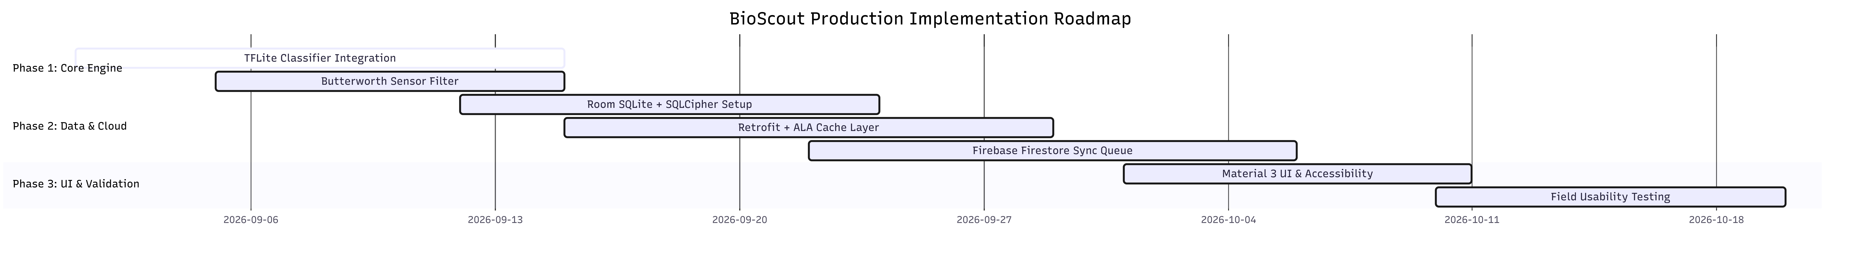

Enterprise Risk Register
- Risk 1: TFLite Inference Latency on Low-End Devices
  - Impact: High frame drop rates during active camera preview.
  - Mitigation: The engine will utilize 8-bit quantized models and delegate matrix math to the NNAPI/GPU delegate, maintaining a fallback to asynchronous worker threads.
- Risk 2: Atlas of Living Australia API Outages or Throttle Caps
  - Impact: Context query failure causing blank location priors.
  - Mitigation: The client will implement exponential backoff retry logic alongside a Room spatial cache, falling back gracefully to deterministic regional data.
- Risk 3: Sensor Unavailability Across Diverse Hardware
  - Impact: Stability gating failure on budget target devices.
  - Mitigation: Runtime capability checks will dynamically deactivate unavailable sensor requirements, reverting smoothly to manual capture modes.

AI Tools and Technologies Acknowledgement:
Google Gemini was utilized during the planning phase of this project plan to assist with text generation, brainstorming workload breakdowns, and editing technical descriptions. The final architecture, logic models, and code verification remain the sole responsibility of the development team

